S1 Appendix
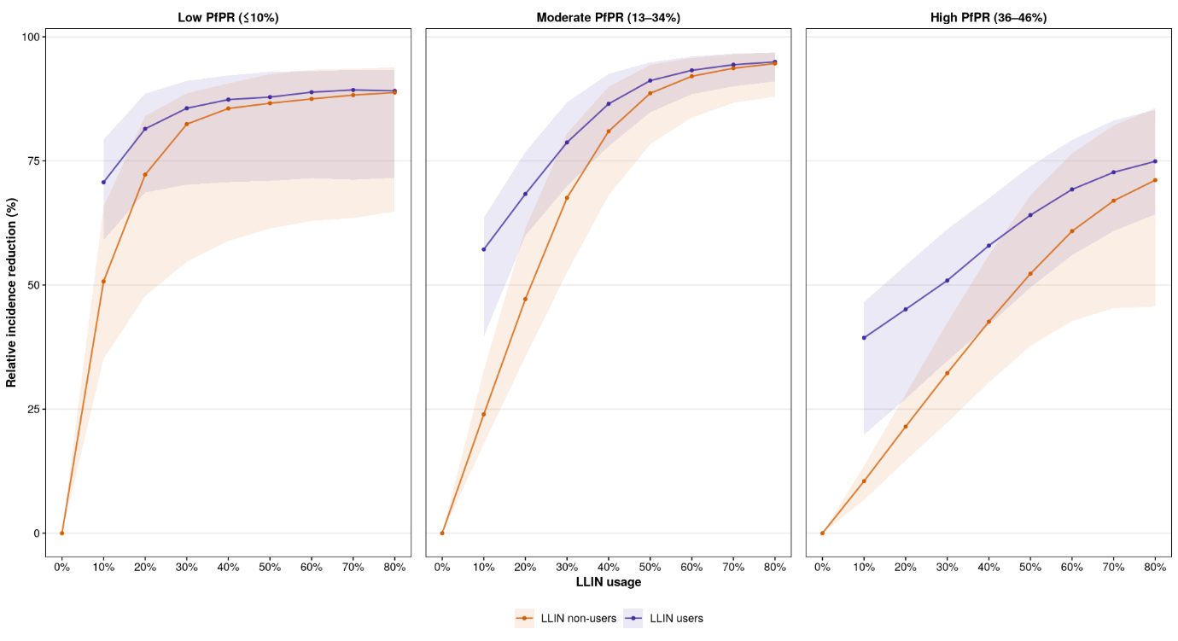
Figure A1: Relative reduction in malaria incidence among LLIN users and non-users. The reduction in incidence is calculated from a counterfactual scenario where nobody in the population is given a net. User and non-user protections are represented here for all LLIN usage levels. The protection for users is shown in purple and non-users in orange. Mean and interquartile range are shown for 10 seeds of each EIR level (EIR levels from 1 to 100) withing each PfPR setting.

Table A1. Overall infections averted at 10 and 80% usage levels
Transmission settings | Usage level | Total averted compared to counterfactual | Total averted compared to counterfactual (%)
Low PfPR (≤10%) | 10% | 1,331.20 | 51.2
Low PfPR (≤10%) | 80% | 1,855.18 | 71.4
Moderate PfPR (13–34%) | 10% | 3,121.16 | 22.8
Moderate PfPR (13–34%) | 80% | 12,612.56 | 92.1
High PfPR (36–46%) | 10% | 1,866.63 | 9.0
High PfPR (36–46%) | 80% | 13,072.15 | 63.3
Values are based on the simulation scenarios used in the analysis.

Table A2. Infections averted at 10 and 80% usage levels by usage status
Transmission settings | Usage level | Usage status | Infections averted | Infections averted (%)
Low PfPR (≤10%) | 10% | users averted | 159.69 | 12.0
Low PfPR (≤10%) | 10% | nonusers averted | 1,171.51 | 88.0
Low PfPR (≤10%) | 80% | users averted | 1,490.13 | 80.3
Low PfPR (≤10%) | 80% | nonusers averted | 365.05 | 19.7
Moderate PfPR (13–34%) | 10% | users averted | 618.27 | 19.8
Moderate PfPR (13–34%) | 10% | nonusers averted | 2,502.89 | 80.2
Moderate PfPR (13–34%) | 80% | users averted | 10,113.31 | 80.2
Moderate PfPR (13–34%) | 80% | nonusers averted | 2,499.25 | 19.8
High PfPR (36–46%) | 10% | users averted | 529.91 | 28.4
High PfPR (36–46%) | 10% | nonusers averted | 1,336.72 | 71.6
High PfPR (36–46%) | 80% | users averted | 10,411.37 | 79.6
High PfPR (36–46%) | 80% | nonusers averted | 2,660.77 | 20.4
Values are based on the simulation scenarios used in the analysis.

